**Project Initialization and Planning Phase**

| Date | 16 June 2025 |
| --- | --- |
| Team ID | SWTID1750052396 |
| Project Name | Analysis of medium app reviews from google play store |
| Maximum Marks | 3 Marks |

**Problem Statement**

The current loan application process challenges customers, impacting their journey and overall satisfaction. Applicants, particularly those seeking urban property loans, encounter hurdles such as limited co-applicant income and a cumbersome application process. These challenges lead to a less-than-optimal customer experience, potentially affecting trust and satisfaction. To enhance our services and improve customer perceptions, we aim to address these pain points. By understanding customers' specific frustrations during the application journey and implementing solutions, we can create an efficient, user-friendly experience that aligns with our customer's expectations and fosters a positive relationship with our brand.

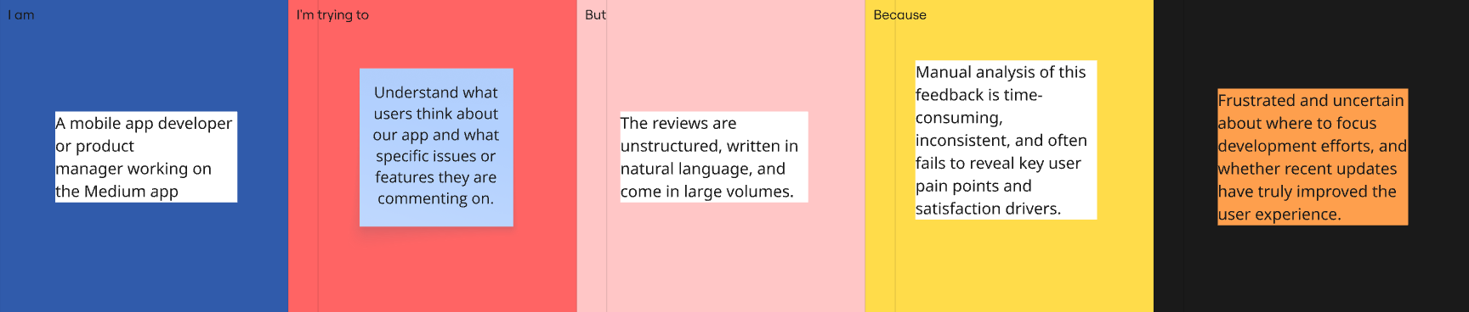

|  |  |  |  |  |  |
| --- | --- | --- | --- | --- | --- |
| **Problem**  **Statement (PS)** | **I am**  **(Customer)** | **I’m trying to** | **But** | **Because** | **Which makes me feel** |
| PS-1 | A mobile app developer or product manager working on the Medium app | Understand what users think about our app and what specific issues or features they are commenting on. | The reviews are unstructured, written in natural language, and come in large volumes. | Manual analysis of this feedback is time-consuming, inconsistent, and often fails to reveal key user pain points and satisfaction drivers. | Frustrated and uncertain about where to focus development efforts, and whether recent updates have truly improved the user experience. |